**Exercise 6-1 3DGAN**

Jirayu Petchhan, D10907801

Load pretrained model

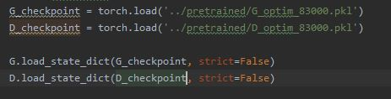

Training 1000 epochs and the result of different generated 3D 10 images

|  |  |
| --- | --- |
| the epoch | Generated 3D output image |
| 1 |  |
| 2 |  |
| 3 |  |
| 4 |  |
| 5 |  |
| 6 |  |
| 7 |  |
| 8 |  |
| 9 |  |
| 10 |  |

The training results.

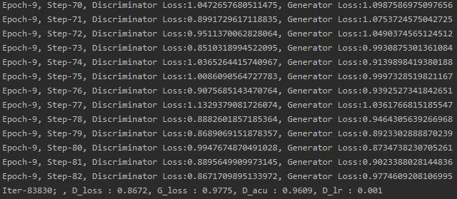

**WGAN-GP implementation and training with only 500 steps (~ 6-7 epochs)**

Adding the WGAN-GP function from exercise 4-3

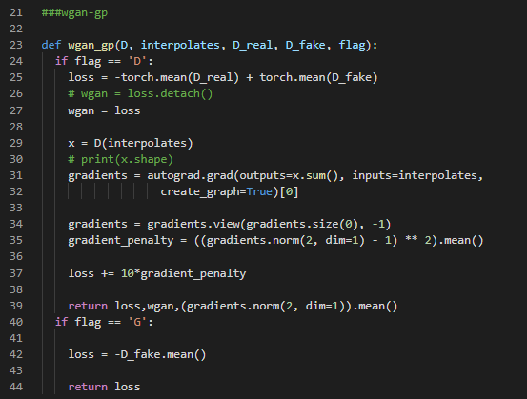

Training setup

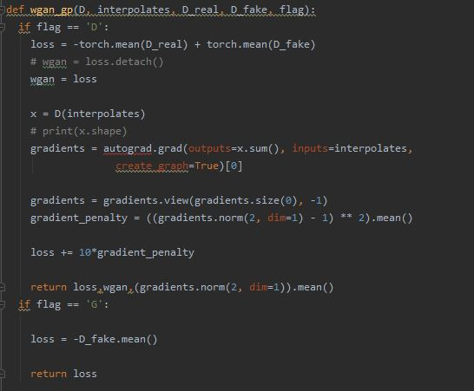

Generative network training

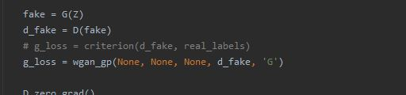

Discriminative network training

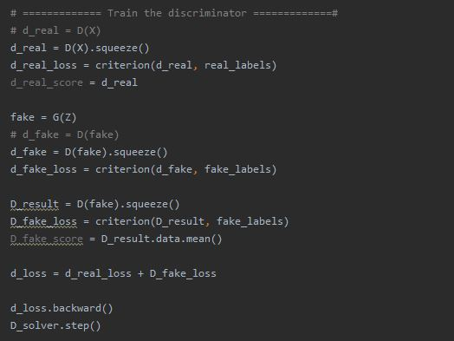

|  |  |
| --- | --- |
| the epoch | Generated 3D output image |
| 1 |  |
| 2 |  |
| 3 |  |
| 4 |  |
| 5 |  |
| 6 |  |

The training results.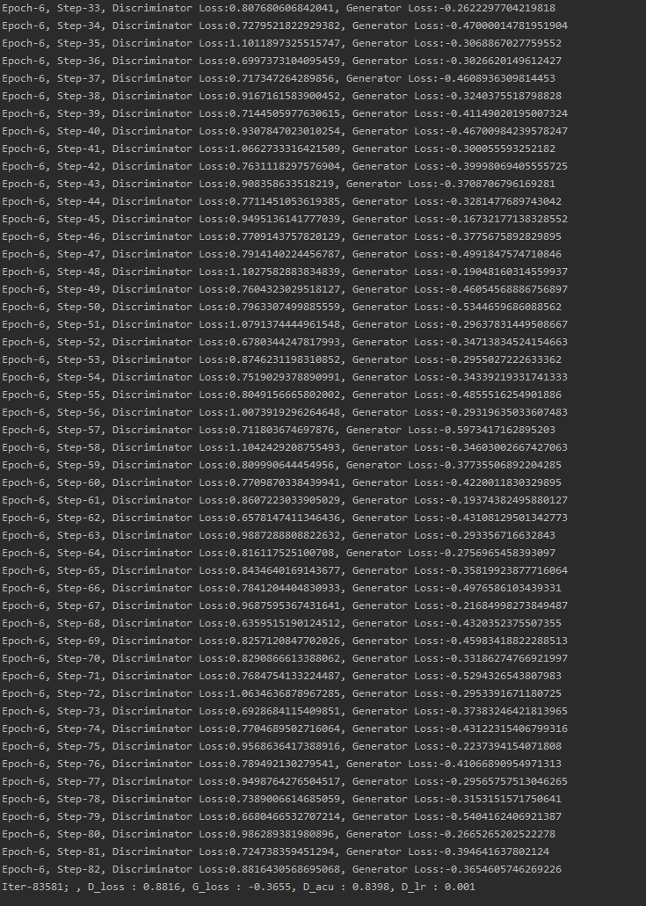

**Conclusion**

We will see that the pretrained model with non-saturated loss when training finished there are the result close to training with WGAN-GP (the different of D_loss have 0.02 while G_loss have the different objective of loss).